Hands On Assessment

Srishti Vermani

Data Preparation:

1. Uploading Data on blob stroage

1. Taking data from blob storage into ml studio

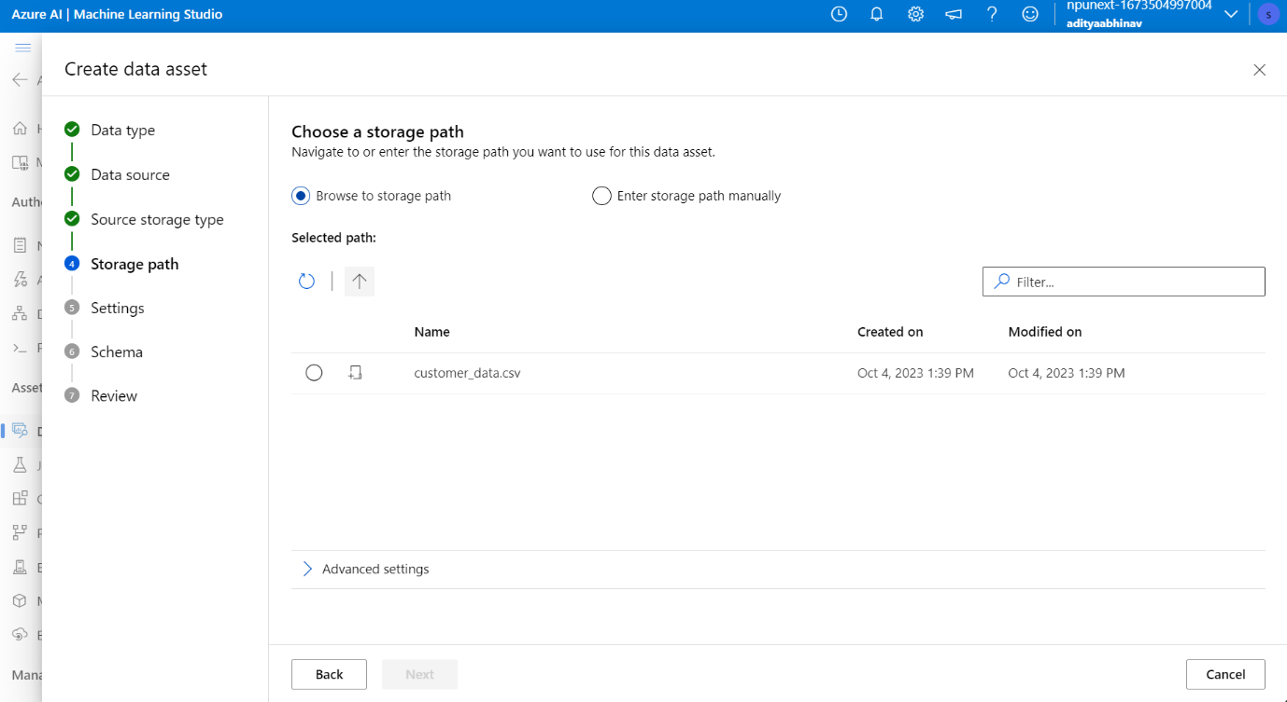

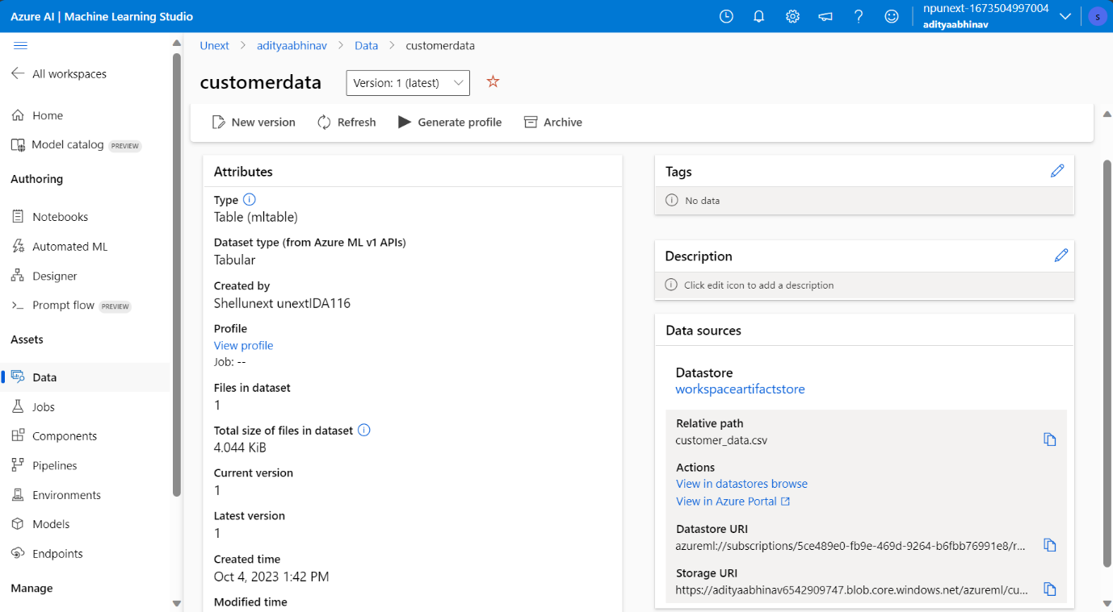

1. Creating Compute

1. Selecting feature/columns

1. Cleaning missing data

1. Handling Outliers

1. Normalizing data

1. Splitting Data

1. Model Selection

1. Hyperparameter tuning

1. Flow

1. Job Submitted

1. Job Running

1. Score

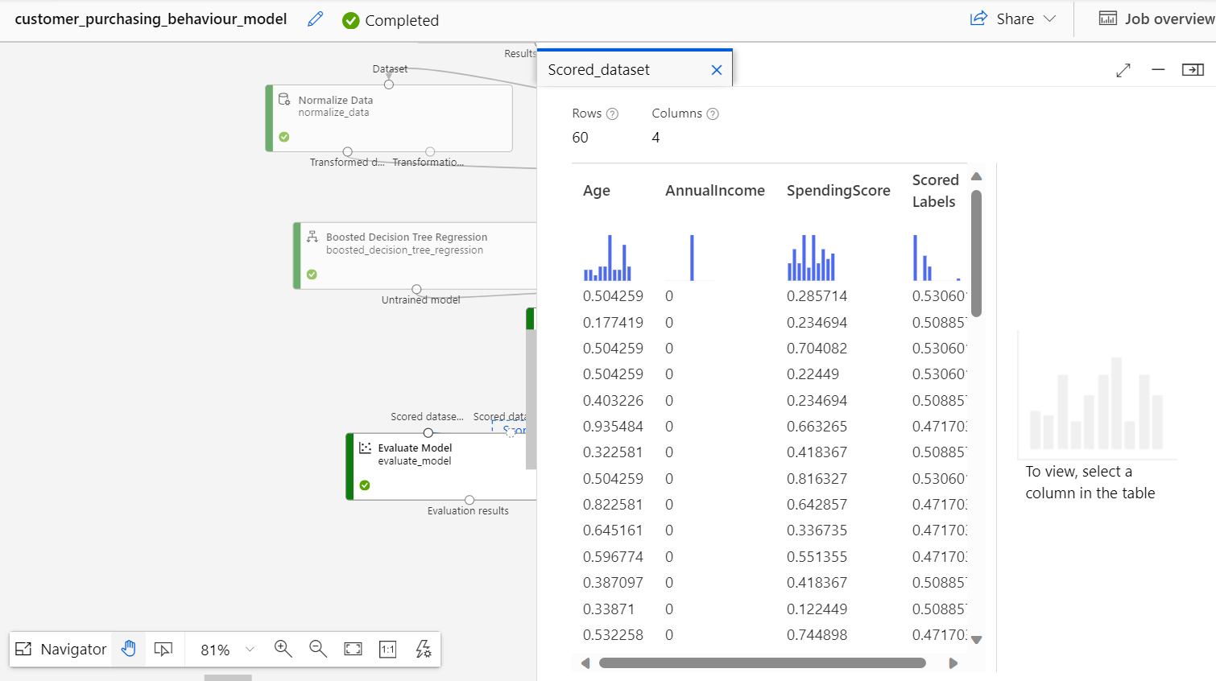

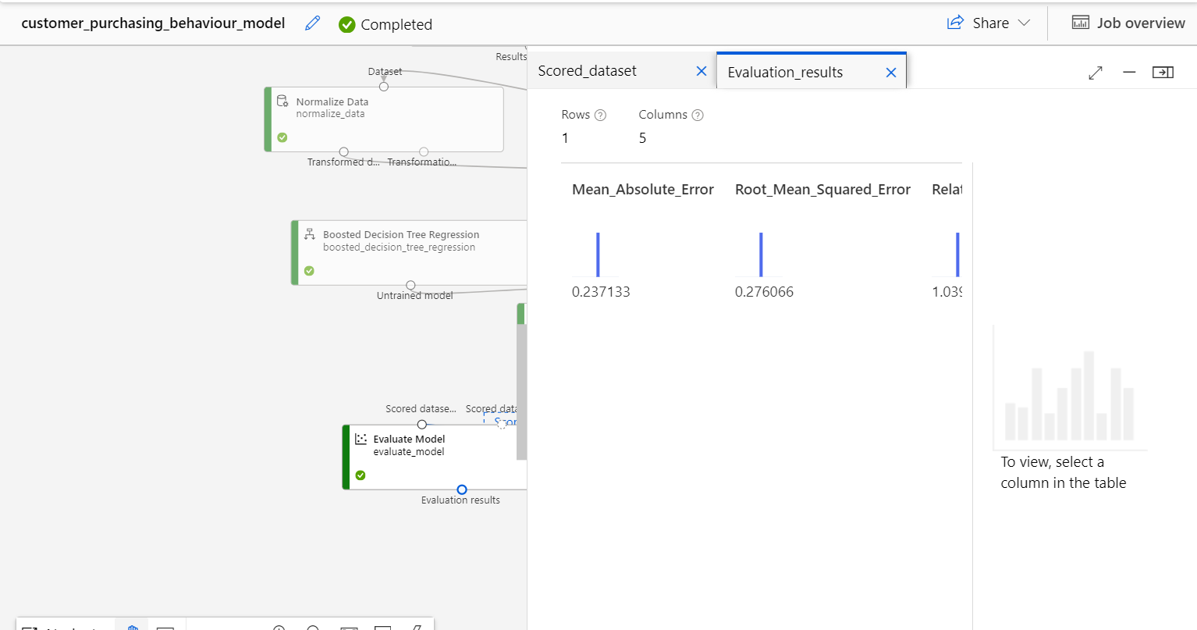

Q1.

1. Data collection: Collect the data that we shall use to train the model.
2. Data cleaning: Checking for any missing, duplicate or inconsistent data and clean it. We can use various methods such as filling in missing values, removing noisy data and outliers, or resolving conflicts.
3. Data transformation: Normalizing data to reduce dimensions and noise. You can use various methods such as scaling, encoding, or feature engineering to transform your data into a suitable format for your model.
4. Data reduction: Sample data records or attributes for easier data handling. You can use various methods such as filtering, aggregation, or dimensionality reduction to reduce the size and complexity of your data.

Q2. LSTM is a machine learning algorithm that can learn from sequential data and predict customer purchasing behavior in the given scenario. It is chosen because it can handle various types of data, cope with noise and uncertainty

Q4. Hyperparameter tuning is a technique where we adjust the parameters of a machine learning model to improve its performance and accuracy. Hyperparameters are the settings that control how the model learns from the data, such as the learning rate, the number of hidden layers, the regularization strength, etc. Hyperparameters are different from the model parameters, which are the weights and biases that are learned during the training process.